Understanding and quantifying the potential scaling in geothermal reservoirs

Carlos Andres Rivera Villarreyes^{1*}, Francesca De Gaspari¹, Sophie Gruschka²
DHI, Am Studio 26, 12489 Berlin, Germany¹
DHI-FEFLOW, Volmerstraße 28, 12489 Berlin, Germany²
(*) cvi@dhigroup.com

The Title of abstract should be written in Arial 11. The entire list of authors should be included in Arial 10 and Italic. The list of affiliations is in Arial 9. The email address corresponds to the presenting author and the one communicating with DHI.
Below you find an example of an abstract. Maximum number of words is 400 and the spacing after paragraph is 8 pt. At the end, you should a visual abstract and its corresponding legend. Please make sure that the image quality is good enough for printing and website. A compendium of abstracts will be published at the end of the conference.
In Germany, there are three suitable regions for (hydrothermal) geothermal use: The Upper Rhine Graben, the North German Basin and the North Alpine Foreland Basin. The reservoir temperature in the multiple aquifer layers is normally higher than 65 °C, which allows direct use for district heating purposes. They are subjected to geochemical challenges due to its local minerology. Scaling is a common and widespread challenge known from numerous deep geothermal projects, particularly linked to highly saline brines encountered in the North German Basin and the Upper Rhine Graben. There is a large diversity of oversaturated minerals under operational conditions leading to scaling. Most common groups are carbonates, silica, and sulphides. Scalings can substantially affect the geothermal energy productivity index by reducing heat transfer and by physically clogging pipe systems. They have to be removed regularly, resulting in additional operation costs and downtimes of the plant.
The FEFLOW is used to model the subsurface flow and heat transport conditions. Additionally, FEFLOW is used to model the reactive transport mechanisms associated with scaling in deep geothermal reservoirs in Germany. One of the most discussed alternatives to minimize the scaling effect is the injection of CO₂ to reduce the pH value nearby the wells. Such a scenario is modelled in this work, considering the geothermal doublet. This helps us to evaluate whether injected CO₂ produces (or not) unexpected side effects on the production well (e.g. permeability decrease – reservoir damage). Here, we present our most recent simulation results.
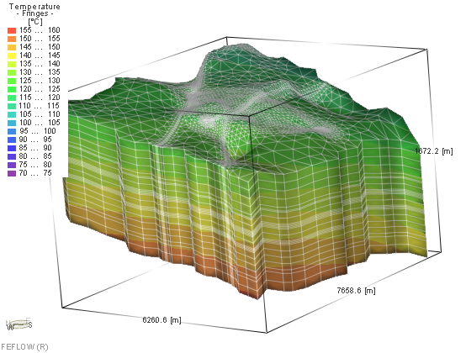
Figure. Distribution of initial temperature in the 3D FEFLOW model.

